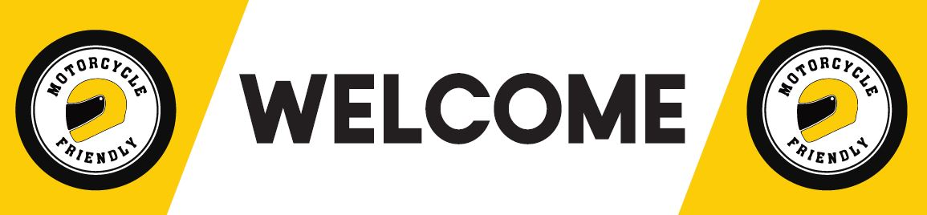

APPLICATION FORM – MOTORCYCLE FRIENDLY BUSINESS

Applicants Name:

Business Name: ABN:

Address:

Email: Phone Number:

Business Category:

Accommodation
Service Station
Café/Restaurant
Hotel
Motorcycle Services
Retail
Other:

Business Description:

Website/Social Media:

Are you in an approved motorcycle friendly town? YES NO

What makes your business motorcycle friendly?

Email completed form to: motorcyclefriendly@outlook.com

Entry into the motorcycle friendly program is subject to approval by M & C Services and the Motorcycle Council of NSW.

The motorcycle friendly program is proudly supported by:

